Voice of America (VOA)

🔹 Definition
# Source: ScreenShots Source: Provided by: [Persons Table -> ID Column: 1, Name_En Column: Motasem Essam] -> Tool: [Lightshot Program] -> From [Site: https://www.voanews.com/] on [11/13/2025]
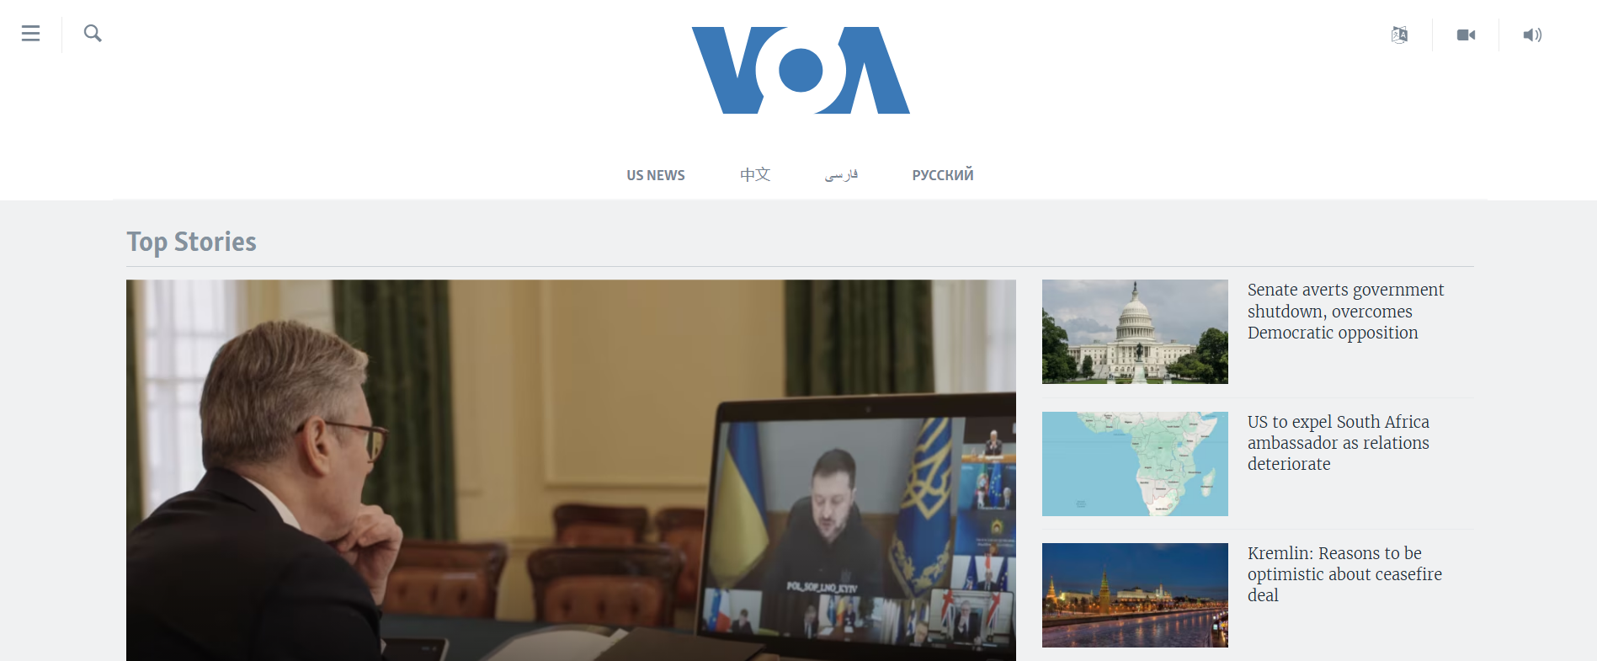
# Source: AI Source: Provided by: [Data Path: Persons Table -> ID Column: 1, Name_En Column: Motasem Essam] -> From: [ChatGPT] on [11/13/2025]
Voice of America (VOA) — https://www.voanews.com/ — is the official international news and broadcast service of the United States government. Here’s a detailed breakdown:

📌 Overview
# Source: AI Source: Provided by: [Data Path: Persons Table -> ID Column: 1, Name_En Column: Motasem Essam] -> From: [ChatGPT] on [11/13/2025]
- Voice of America is a U.S. government-funded multimedia news organization.
- It provides news, information, and cultural programming in multiple languages to international audiences.
- The website acts as a portal for accessing articles, videos, radio broadcasts, and live streaming.

⚡ Key Features
# Source: AI Source: Provided by: [Data Path: Persons Table -> ID Column: 1, Name_En Column: Motasem Essam] -> From: [ChatGPT] on [11/13/2025]
- News Coverage: Global and U.S. news, politics, economy, science, health, and culture.
- Multimedia Content: Articles, podcasts, videos, and live radio streaming.
- Language Options: Offers content in dozens of languages to reach audiences worldwide.
- Educational Resources: Some sections include English learning resources and cultural programs.

✅ Purpose
# Source: AI Source: Provided by: [Data Path: Persons Table -> ID Column: 1, Name_En Column: Motasem Essam] -> From: [ChatGPT] on [11/13/2025]
- To provide accurate, timely, and unbiased news to international audiences.
- Promotes understanding of U.S. policies, culture, and values abroad.

🛡️ Safety & Legality
# Source: AI Source: Provided by: [Data Path: Persons Table -> ID Column: 1, Name_En Column: Motasem Essam] -> From: [ChatGPT] on [11/13/2025]
- Fully legal and safe.
- Operated by the U.S. government, with editorial independence.
- No pirated software or malware risks.

📌 Summary
# Source: AI Source: Provided by: [Data Path: Persons Table -> ID Column: 1, Name_En Column: Motasem Essam] -> From: [ChatGPT] on [11/13/2025]
Voice of America is a trusted government news outlet providing global news and cultural content in multiple languages. Its website is a safe, legal, and authoritative source for international news.

